TEAM -4
Image Compression over MNIST
Software Development Tools

TensorFlow:
TensorFlow is an open source software library for high performance numerical computation. Its flexible architecture allows easy deployment of computation across a variety of platforms (CPUs, GPUs, TPUs), and from desktops to clusters of servers to mobile and edge devices. Originally developed by researchers and engineers from the Google Brain team within Google’s AI organization, it comes with strong support for machine learning and deep learning and the flexible numerical computation core is used across many other scientific domains.
Reason for choosing TF over Keras:
Keras is high level library to build complex neural network, it is more user- friendly and it is relatively easy to build the network in it. But the points that go against the Keras are
1. Flexibility: Keras being higher level you can’t tweak it much as much as you can do with TF which is needed when you wanted to change some different cost function or you want to define some different other metric. TF being low level library provides more flexibility.
2. Functionality: Although Keras provides all the general-purpose functionalities for building Deep learning models, it doesn’t provide as much as TF. TensorFlow offers more advanced operations as compared to Keras. This comes very handy if you are doing a research or developing some special kind of deep learning models.

3. Threading and Queues: Queues are a powerful mechanism for computing tensors asynchronously in a graph. Similarly, you can execute multiple threads for the same Session for parallel computations and hence speed up your operations.

4. Control over Network: TF provides more control over the network. We can decide which step should be trained or not, operation on weights and gradients can be controlled, etc.
Due to all of the above, we choose tensorflow as tool to learn and explore more about the project and try out new things.

Convolutional Neural network:
Traditional MLP is useful for many purposes but it fails in case of image. The fact that MLP treats complete image as individual pixels and hence it is not able to maintain the spatial relationship between the small elements[pixels] and hence it is not as effective as it should have been.
Convolutional neural network has layers of convolution and pooling. Convolutional layers take advantage of the local spatial coherence of the input. This is only possible because we assume that spatially close inputs are correlated. More over CNNs are able to cut down on the number of parameters by sharing weights. This makes them extremely efficient in image processing, compared to multi-layer perceptron.
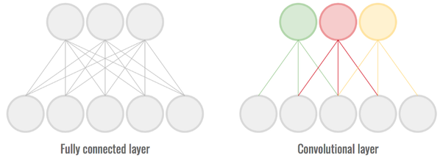
In Pooling layer of CNN, input is scaled down to reduce even more the number of parameters, while conserving enough information which increases the efficiency of model by consuming less space and also less connections.
Hence using CNN over MSP during the image compression is feasible and more effective.

Activation Function:
Activation functions are used to introduce non-linearity in our neural network. Non-linear functions are those which have degree more than one and they have a curvature when we plot a Non-Linear function. Now we need a Neural Network Model to learn and represent almost anything and any arbitrary complex function which maps inputs to outputs. Neural-Networks are considered Universal Function Approximators. It means that they can compute and learn any function at all. Almost any process we can think of can be represented as a functional computation in Neural Networks. Hence, we need Non-linearity in our model.There are various activation function available for neural networks. We would be using Leaky RELU (Rectified Linear Units). Other available are tanH & Sigmoid.
Sigmoid: Sigmoid function lies between 0 and 1 only and it is effective where we have to predict the probabilities of the classes or features.
Tan H: TanH lies between -1 and 1 and works similar to Sigmoid but it is smooth as compared to sigmoid. The advantage of tanh is that negative inputs are mapped to high negative values and zero values are mapped to values closer to the zero and hence it is effective when you perform the classification between the elements.
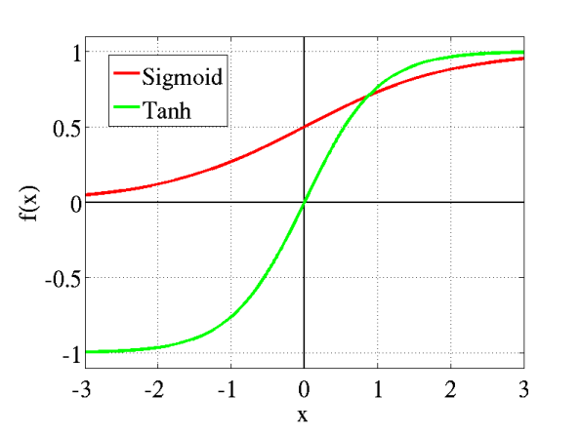
Sigmoid v/s Tanh

RELU: RELU lies in the range of 0 to infinity. All the negative values are considered to be zero and all the positive values have same values. Drawback of RELU is that, all the negative values becoming zero suddenly which decreases the ability of the model to fit to the data properly. means any negative input given to the RELU activation function turns the value into zero immediately in the graph, which in turns affects the resulting graph by not mapping the negative values appropriately.
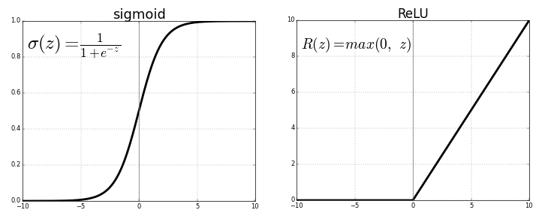
Sigmoid v/s RELU
Leaky RELU: It’s a variant of the RELU which tries to solve the dying problem of RELU. The leak helps to increase the range of RELU function to negative to positive infinity by leaking it to value of 0.01.
Since the Leaky_Relu is most adaptive and used function and it also suits our requirements we would be using this.
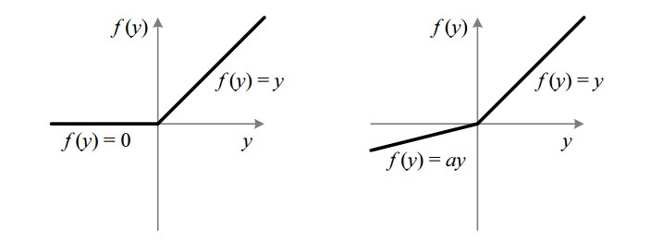
RELU vs Leaky RELU

Optimization function:
Optimization algorithms helps us to minimize (or maximize) an Objective function (another name for Error function) E(x) which is simply a mathematical function dependent on the Model’s internal learnable parameters which are used in computing the target values(Y) from the set of predictors(X) used in the model. There are different optimizing functions available one of the easiest one stands out is the Gradient Descent. But it is very basic and hence not efficient for all the networks and hence we use various improved variants of it.
One of such variants is adding the momentum. High variance of the values in the Gradient descent makes it hard to reach convergence and hence we use momentum which accelerates the Gradient descent by navigating along the particular direction and keeping that information in a vector and update the vector of past values. ADAM optimizer is one of such variant where it computes adaptive learning rates for each parameter. In addition to storing an exponentially decaying average of past squared gradients like AdaDelta, ADAM also keeps an exponentially decaying average of past gradients like momentum.
ADAM works well in practice and compares favourably to other adaptive learning-method algorithms as it converges very fast and the learning speed of the Model is quite Fast and efficient and also it rectifies every problem that is faced in other optimization techniques such as vanishing Learning rate, slow convergence or High variance in the parameter updates which leads to fluctuating Loss function. Hence, we decided to use the ADAM optimizer as our optimizing function to optimize the weights of our Neural Network and get the faster convergence rate.

OpenCv :
OpenCV (Open source computer vision) is a library of programming functions mainly aimed at real-time computer vision. Its manily used for iamge proceesing.
OpenCV has a modular structure, which means that the package includes several shared or static libraries. The following modules are available:
- Core functionality - a compact module defining basic data structures, including the dense multi-dimensional array Mat and basic functions used by all other modules.
- Image processing - an image processing module that includes linear and non-linear image filtering, geometrical image transformations (resize, affine and perspective warping, generic table-based remapping), color space conversion, histograms, and so on.
- video - a video analysis module that includes motion estimation, background subtraction, and object tracking algorithms.
- calib3d - basic multiple-view geometry algorithms, single and stereo camera calibration, object pose estimation, stereo correspondence algorithms, and elements of 3D reconstruction.
- features2d - salient feature detectors, descriptors, and descriptor matchers.
- objdetect - detection of objects and instances of the predefined classes (for example, faces, eyes, mugs, people, cars, and so on).
- highgui - an easy-to-use interface to simple UI capabilities.
- Video I/O - an easy-to-use interface to video capturing and video codecs.
- gpu - GPU-accelerated algorithms from different OpenCV modules.
- ... some other helper modules, such as FLANN and Google test wrappers, Python bindings, and others.

OpenCv Usage :
1. image Enhancment
2. Object classificationan and tracking
3. Face recognition and detection
as our project is based on image compression, and for that we need image enhancement so that we have used OpenCv library.

